Patrick Snell, Brad Bayuga

COMP 3700

Course Project Iteration 2 – Implementation/Testing

**Task 1 Implementation**

Please see the running version on GitHub which implements the eight use cases:

1) As a user (cashier or manager), I want to log in the system

2) As a user, I want to change my login password

3) As a user, I want to change my display/profile photo

4) As a cashier, I want to check out an order

5) As a manager, I want to add a new product into the system's database

6) As a manager, I want to update a current product in the system's database

7) As a manager, I want to create a new user, assign role (e.g. manager or cashier), generate a default password for a new user

8) As a manager, I want to view and sort the business report: e.g., what products are sold, how many units, how much revenue...

**NOTE: Some of the code in the running version was taken from Dr. Nguyen’s demo on canvas. We do not claim this code used from the demo to be our own.**

**Task 2 Testing**

User Case 1) As a user (cashier or manager), I want to log in the system

By testing the Login use case, a user would type in a new user id and password. Observe the Users Table from the Store Management System database.



The first test, observes what happens when a manager types in a valid user id and password. When the system starts, the Login screen appears and a manager types in a user id and password.

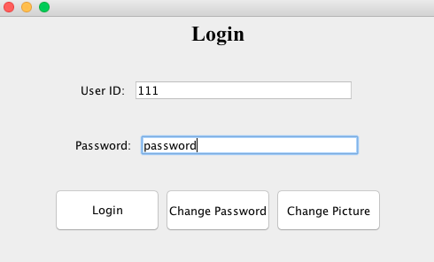

Once the user selects “Login”, the user is directed to the Manager Screen since this user id and password are valid and the user is identified to be a manager.

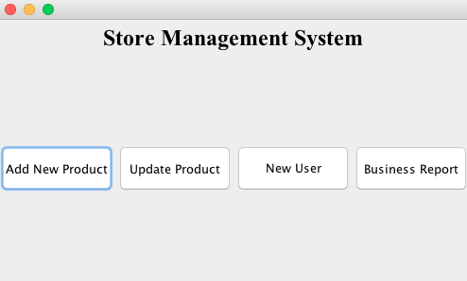

The second test for Use Case #1, observes what happens when a cashier types in a valid user id and password. When the system starts, the Login screen appears and a manager types in a user id and password.

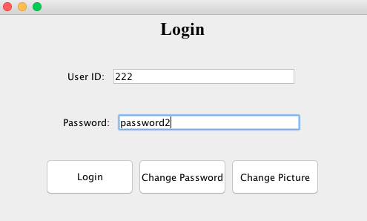

Once the user selects “Login”, the user is directed to the Cashier Screen since this user id and password are valid and the user is identified to be a cashier.

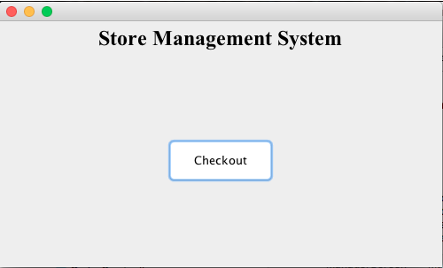

The third test for Use Case #1, observes what happens when a user types in either an invalid user id or password. When the system starts, the Login screen appears and a manager types in an invalid user id or password.

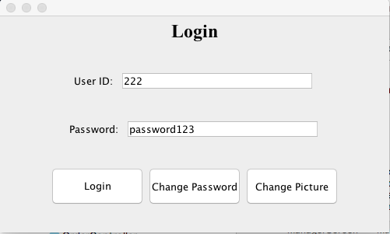

Once the user selects “Login”, an error message appears. Notice that even though “222” is a valid User ID, “password123” is not the corresponding password for “222”.

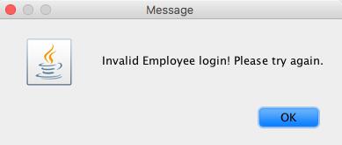

Use Case 2) As a user, I want to change my login password

By testing the Password Change use case, a user would type in a current user id and password and then a new password to replace the current one. Observe the Users Table from the Store Management System database.



The first test, observes what happens when a user types in a valid current user id and password and then types in a new valid password. When the system starts, the Login screen appears and then the user selects the option to Change Password. 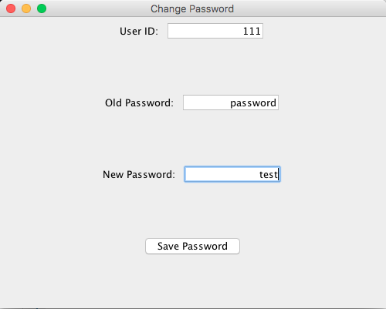

After the user selects “Save Password”, the new password has been saved to the database. This is reflected by the Users Table.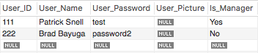

The second test, observes what happens when a user types in an invalid current user id and password and then types in a new password. When the system starts, the Login screen appears and then the user selects the option to Change Password.

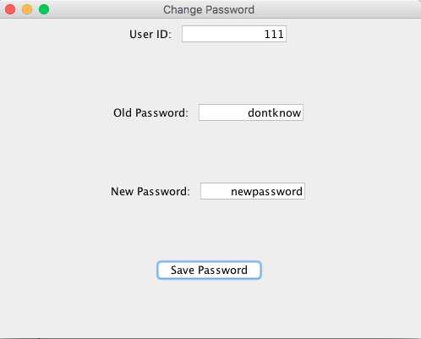

After the user selects “Save Password”, an error message appears because this is an incorrect old password. The Users table in the database is not changed.

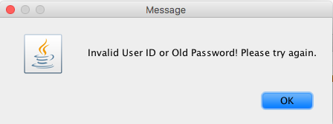

Use Case 3) As a user, I want to change my display/profile photo

Use Case 4) As a cashier, I want to check out an order

By testing the Checkout use case, a cashier would type in the barcode number and the quantity. The following test is below, which shows what occurs when valid values are entered. First, observe the Product Table from the Store Management System database.

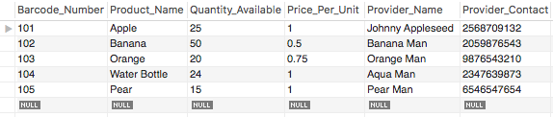

When the system starts, the Login screen appears and then the cashier logs in and is then directed to the cashier screen. The cashier then selects “Checkout”.

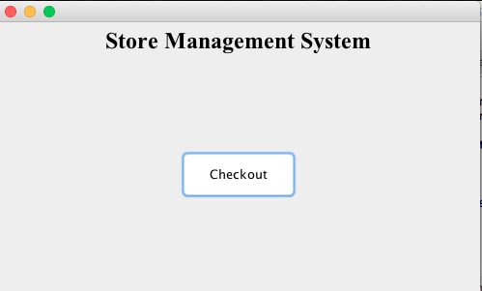

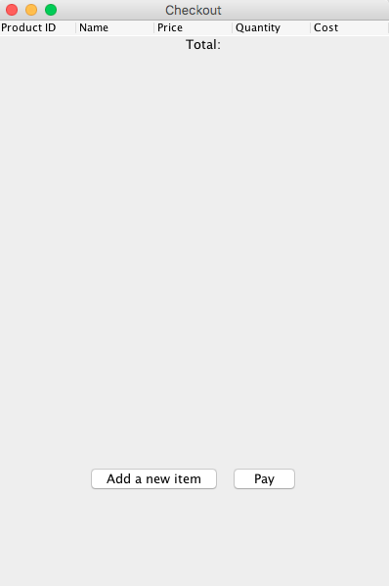

After selecting “Add a new item”, the user must type in a valid barcode number and quantity.

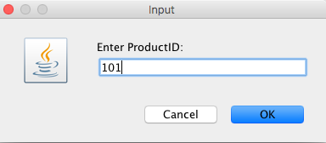

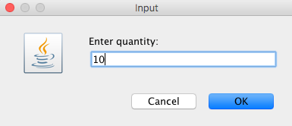

As can be seen, Apple is updated on the screen and the Product Table from the Store Management System database is updated as well.

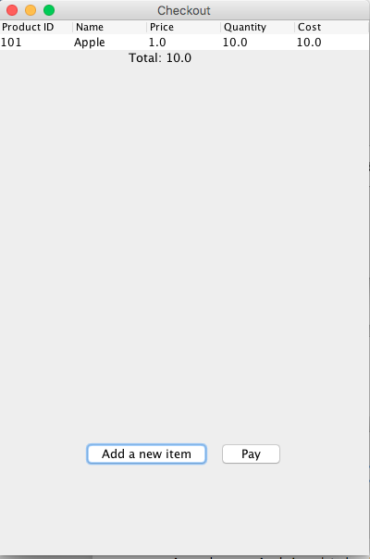

Since ten units of Apple have been checked out, the Quantity Available field in the Product table for Apple has been reduced from 25 to 15.

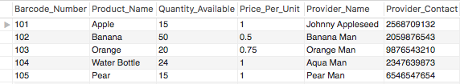

Use Case 5) As a manager, I want to add a new product into the system's database

This tests adding a new product. First observe the current Product table.

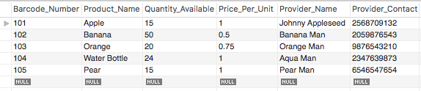

Now a manager logs into the system and then selects to add a new product. The Product screen appears.

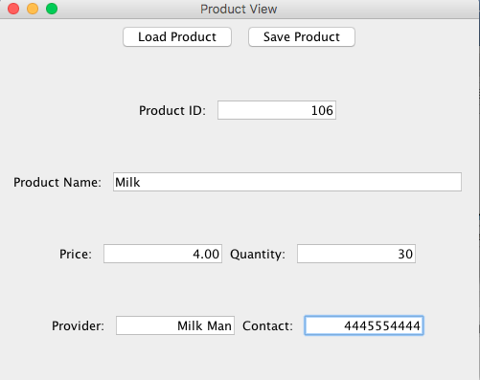

After the manager types in the new product information and selects “Save”, the new product is saved to the Product table. This is reflected in the Product table below as the product Milk has been added.

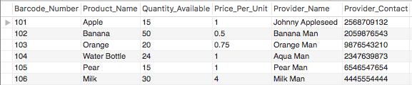

Use Case 6) As a manager, I want to update a current product in the system's database

This tests adding updating an existing product. First observe the current Product table.



Now a manager logs into the system and then selects to add a update and existing product. The Product screen appears.

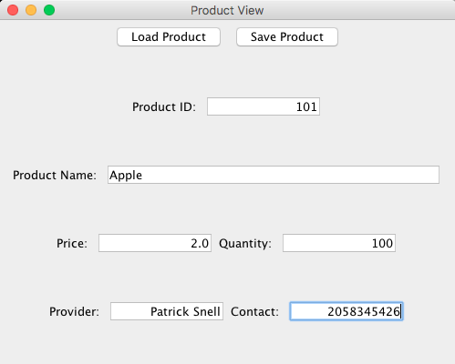

After the manager types in the new product information and selects “Save”, the product is updated in the Product table. This is reflected in the Product table below as Apple’s price, quantity, provider and provider contact have been updated.

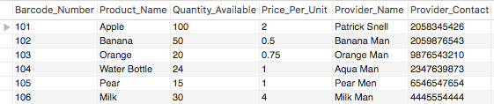

Notice that when a manager types in an invalid product id, an error message is printed. As a result, no product will be updated because a valid product id was not entered.

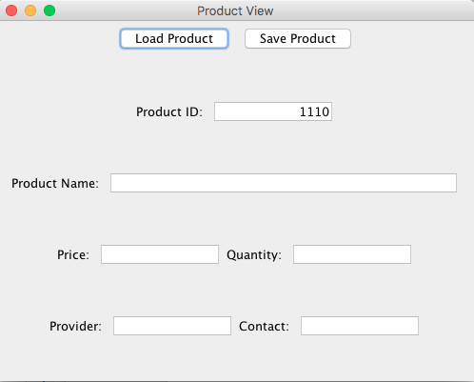

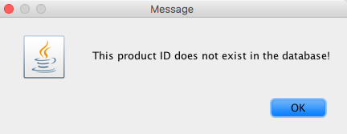

Use Case 7) As a manager, I want to create a new user, assign role (e.g. manager or cashier), generate a default password for a new user

By testing the Add User use case, a manager would type in a new user id, user name, password and role. Observe the Users Table from the Store Management System database.



When the system starts, the manager logs in and then selects to Add A New User.

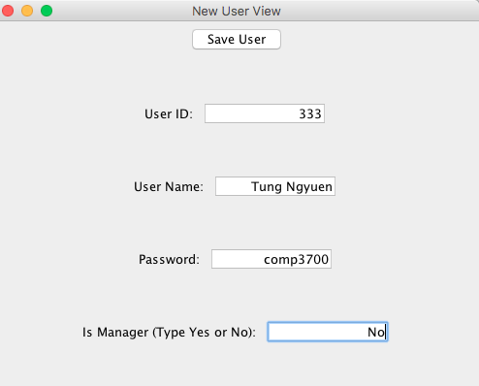

When a manager has typed in the necessary information and selects “Save User”, this new user is added to the User table in the database, which can be seen below. 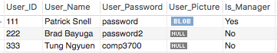

Use Case 8) As a manager, I want to view and sort the business report: e.g., what products are sold, how many units, how much revenue...